**PRESS REPORT**  
**INTERNATIONAL WOMEN’S DAY CELEBRATIONS 2025**

**Jerusalem College of Engineering Celebrates Women’s Day in collaboration with Swadeshi Shodh Sansthan Tamilnadu chapter**

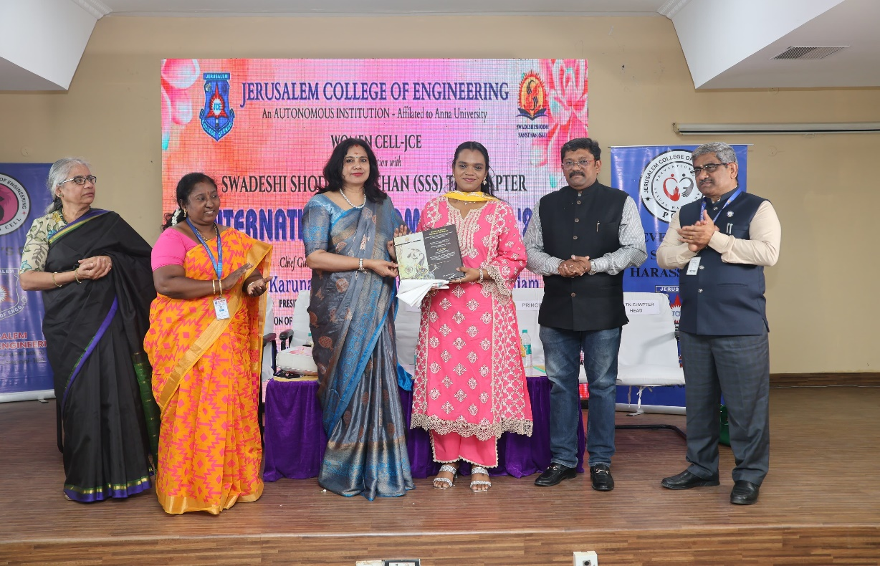

Chennai, March 8, 2025 – Jerusalem College of Engineering (JCE) marked International Women’s Day with an inspiring and empowering celebration organized by the Women Cell - JCE in association with Swadeshi Shodh Sansthan (SSS) TN Chapter. The event, held at the college auditorium, witnessed the participation of esteemed guests, faculty, and students.

The occasion was graced by Smt. Karuna Gopal, President of the Foundation of Futuristic Cities, as the Chief Guest. Thiru. M Balasubramaniam, Deputy Chairman of the MOE - AICTE Investor Committee, was the Guest of Honour. With good wishes of Managing Trustee & Chairperson of JCE, Dr. M. Mala and Trust Secretary, Jerusalem Educational Trust and Tagore Group of Institutions Shri G. Manikandan, the program was presided over by Ms. Rakshana Trustee and Chief Executive Officer, JCE. Swadeshi Jagran Manch All India head Thiru R Sundaram and Former Union Minister for Railways Thiru Suresh Prabhu had sent their best wishes for the event. The presence of the dignitaries added immense value to the celebration, emphasizing the significance of women's empowerment and leadership in today’s world.

The event commenced with the traditional Tamil Thai Vazhthu and the lighting of the Kuthu Vilakku, symbolizing wisdom and knowledge. Ms. S. Bhavanisankari, Chairperson of Women Cell - JCE, welcomed the gathering, followed by an insightful presentation about Swadeshi Shodh Sansthan by Ms. Mythili Parthasarathy, Head of the SSS, TN Chapter.

The Principal of JCE, Dr. Ramesh S, delivered the inaugural address, setting the stage for the event’s key discussions followed by College Video. A felicitation ceremony for honouring our guests was presented by both JCE and SSS.

Ms. Rakshana, Trustee & CEO who had extended unwavering support for the event conveyed her hearty wishes to all the women members and congratulated all the awardees. She also appreciated the organising committee for their triedless efforts in making this event a grand success.

The Guest of Honour, Thiru. M Balasubramaniam highlighted the importance of women’s participation in technological advancements and industry.

The highlight of the event was the Keynote Address by the Chief Guest, Smt. Karuna Gopal, who inspired the audience with her words on the role of women in shaping sustainable and smart urban development.

It was followed by the award ceremony where women achievers in various fields were honoured for their exemplary contribution.

Dr Bharathi for Education, Dr Razia Parvin for Women empowerment, Dr Ramya for Technology, Dr Lakshmi Vijayakumar for Healthcare, Dr Chitra for Resilience and sustainability, Dr Archana Prasad for Commerce and Management studies.

Dr P Anuradha as Best Faculty member of the year, Dr Maheswari for Industry academia collaboration, Dr Pushpa Sadavatti for Economics, Dr Mala as Social Entrepreneur and Dr Thenmozhi for Lifetime Achievement award.

The event concluded with a vote of thanks, followed by the National Anthem, leaving attendees inspired and motivated.

The International Women’s Day Celebrations at JCE successfully reinforced the institution’s commitment to gender equality and the empowerment of women, making it a memorable occasion for all.