INDIAN COUNCIL OF SOCIAL SCIENCE RESEARCH
Research Proposal for Major/Minor Research Projects (2024-25)

Application Number
(To be noted down from the online application)

Applying Under (Put tick mark)
Major Project Proposals with budget up to Rs.30 lakhs |  | Minor Project Proposals with budget up to Rs.15 lakhs

Broad research discipline as per ICSSR list (Refer Clause 1.2 of guidelines)

1 | Name of Project Director
2 | Title of the Research Proposal | Analyzing the Policy Framework and Impact of Vande Bharat Express’s 'Make in India' Tagline on Domestic Air Travel under the Branding of 'Local Flight on Wheels
3 | Abstract  (approx. 300 words) | This study aims to analyze the impact of Vande Bharat Express trains on domestic air traffic patterns across major Indian corridors. The introduction of semi-high-speed Vande Bharat trains represents a significant advancement in India's railway infrastructure, potentially offering a competitive alternative to air travel. This research will examine passenger modal choice behaviour, economic implications, Investment on infrastructure and environmental impacts of this shift in transportation preferences. The study will focus on major routes where Vande Bharat services impact the existing semi and high-speed trains and air connectivity exist, analyzing factors such as infrastructure, travel time, cost efficiency, convenience, and environmental footprint. Using mixed-method research design, the study will collect data from multiple stakeholders including passengers, transportation authorities, and service providers across six states. The findings will contribute to transportation policy planning and sustainable mobility solutions in India.
4 | Introduction of the Proposed Study  (approx. 400 words) | India's transportation sector is witnessing a transformative phase with the introduction of Vande Bharat Express trains. These semi-high-speed trains, capable of running at 160-180 kmph, present a viable alternative to air travel on several routes. The study's relevance stems from the growing need to understand shifting transportation preferences and their implications for sustainable mobility. The introduction of Vande Bharat trains aligns with multiple national objectives: reducing carbon emissions, enhancing connectivity, and promoting efficient public transportation. While air travel has dominated medium to long-distance rapid transport in recent years, the emergence of comfortable and time-competitive rail alternatives necessitates a comprehensive analysis of their impact on travel patterns. This research is particularly timely as India expands its Vande Bharat network, with plans for 400 trains by 2047. Understanding the interplay between rail and air transportation will be crucial for infrastructure planning, policy formulation, and achieving sustainable development goals.
5 | Major Research Works Reviewed:  1) International and  2) National.  Not less than 15 to 20 important works  (approx. 600 words) | - International Studies:  Schedule flexibility and price fluctuations play significant roles in modal shift between rail and air transportation, impacting infrastructure costs and overall efficiency. Research on single-track railway operations suggests that increased schedule flexibility can lead to higher train delays and infrastructure investment requirements (Dick & Mussanov, 2016). Interestingly, while rail is often considered more environmentally friendly, studies have shown that air transport can be more socially efficient than rail, even when accounting for CO2 emissions (Fukuyama et al., 2011). While rail transport has seen increased investment and policy support in some regions (Solak, 2022), the effectiveness of modal shift policies depends on careful consideration of transportation costs, transit times, and service frequency (Kurtuluş & Çetin, 2020). The combined network of high-speed rail (HSR) and air transportation has been shown to improve inter-urban accessibility, outperforming individual networks by substantial margins (Ma et al., 2023). This integrated approach leads to a more equitable distribution of accessibility, particularly benefiting regions surrounding urban centers. Modal shift from road to rail freight transportation has been a focus for policymakers aiming to reduce environmental costs and improve safety (Samimi et al., 2020). Strategies to encourage this shift include fuel price adjustments and improved access to rail transportation. while improved access through shared sidings and rail rate reductions have been explored as potential solutions for increasing rail modal share in rural areas, studies have shown that these measures may have minimal impact (Ko et al., 2023).  - National Studies:  In the Indian context, the integration of rail and air transportation systems is becoming increasingly important due to the growing demand for multi-modal travel options (Sankaranarayanan & Thind, 2017). This shift is driven by factors such as low-cost air travel, rising disposable income, and improved connectivity across various cities. The development of urban-rural transportation integration is crucial for promoting new urbanization and achieving a well-off society in India (Yin et al., 2019). This includes extending public transport facilities to rural areas and improving the coverage of public transport services. However, the current state of Indian airports is inadequate to handle the increasing air traffic, necessitating significant improvements in infrastructure (Ohri, 2012). To address the growing demand and improve connectivity, India requires an efficient and well-equipped airport network throughout the country (Jose & Ram, 2017). he increasing disposable income and connectivity across various cities have led to a rise in multi-modal travel, creating opportunities for seamless integration of rail and air transport (Sankaranarayanan & Thind, 2017). However, the Indian Railways faces challenges in freight transport, with a declining modal share. To address this, there is a need for increased investment in rail infrastructure and technologies to achieve a balanced modal split (Simha, 2016). Additionally, the integration of metro rail systems with feeder modes and park-and-ride facilities has shown potential in increasing ridership and encouraging modal shift from private cars to public transport (Chalumuri et al., 2018). The integration of high-speed rail (HSR) with aviation networks can enhance service frequency and provide an effective strategy for aircraft recovery during disruptions (Liu et al., 2021).
6 | Identification of Research Gap  (approx. 300 words) | While extensive research exists on high-speed rail and air traffic competition globally, there is limited empirical research on the impact of semi-high-speed trains as well as policy frame work in the Indian context. Existing studies primarily focus on either air traffic analysis or railway modernization separately, without examining their interrelationship. The unique aspects of Vande Bharat trains - operating speed, pricing strategy, and service quality - require specific analysis in the Indian context. Additionally, there is a lack of comprehensive studies examining the environmental and economic implications of modal shifts from air to rail travel in India.
7 | Objectives of the Proposed Study  (approx. 200 words) | - To examine the impact of VBE's schedule flexibility on passengers' modal choice decisions  - To evaluate the relationship between scheduling convenience and modal shift patterns  - To analyze the total infrastructure cost of VBE investments in daily routes, comparing semi-high-speed and high-speed trains.  - To analyze the effect of price stability in VBE compared to air travel  - To assess how baggage handling facilities affect travel mode choice  - To evaluate the impact of station/airport accessibility on modal choice  - To measure the effect of service frequency on passenger modal shift
8 | Major Research Questions / Hypotheses  (approx. 200 words) | - How does the introduction of Vande Bharat services affect air passenger volume on competing routes?  - What factors determine passenger choice between air travel and Vande Bharat services?  - What is the price elasticity of demand for both modes of transport?  - How to derive the policy frame work?  Hypotheses:  H1: Schedule flexibility of Vande Bharat Express has a significant positive impact on passenger modal shift from air travel.  H2: Lower price fluctuations in Vande Bharat Express fares compared to airline fares have a significant positive impact on passenger modal shift from air travel.  H3: The infrastructure costs for VBE’s high-speed train routes are significantly higher than those for semi-high-speed routes in daily operations.  H4: More generous luggage allowance policies of Vande Bharat Express have a significant positive impact on passenger modal shift from air travel.  H5: Better accessibility of Vande Bharat Express stations compared to airports has a significant positive impact on passenger modal shift from air travel.  H6: Higher service frequency of Vande Bharat Express has a significant positive impact on passenger modal shift from air travel.  H7: The policy framework supporting the Vande Bharat Express's 'Make in India' initiative positively influences passenger perceptions, leading to increased preference for train travel over domestic air travel, particularly when marketed under the 'Local Flight on Wheels' branding  Proposed Research Model:  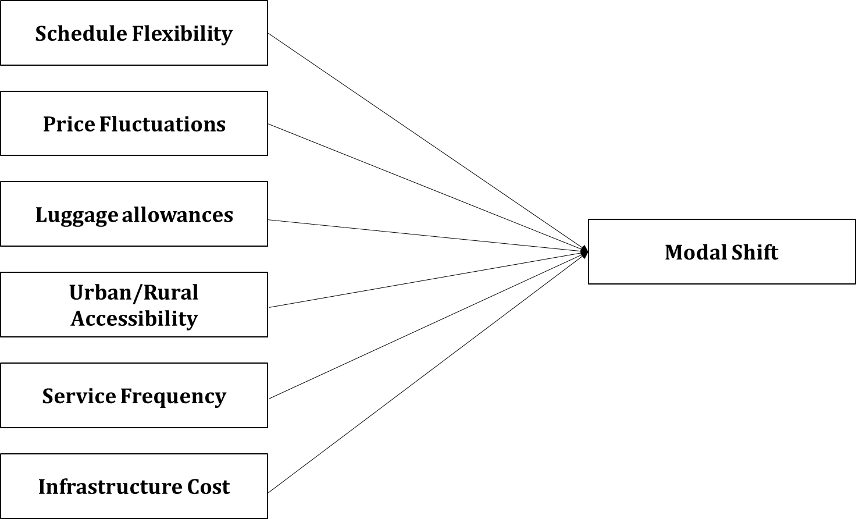
9 | Proposed methodology for the research work (approx. 400 words) | Sample size – 424  Sampling technique – Stratified sampling technique  Population – 3.14 million (VBE passengers), 5 million (Air passengers)  Using the standard statistical formula:  n = [Z²× p(1-p)×N] / [e²(N-1) + Z²×p(1-p)] (Yamane’s Sample size calculation formula)  Where:  N = Population size (8.14 million)  Z = 1.96 (95% confidence level)  e = 5% margin of error (0.05)  p = 50% (0.5) population proportion (maximizes sample size)  Mode-wise Distribution:  - AIR respondents: 260 (61.32%)  - VBE respondents: 164 (38.68%)  Route-wise Distribution:  - Delhi-Varanasi: 106 respondents  - Mumbai-Ahmedabad: 93 respondents  - Chennai-Mysuru: 76 respondents  - New Delhi-Bhopal: 85 respondents  - Mumbai-Solapur: 64 respondents  Demographic Distribution:  - Gender balance  - Age groups: 18-30, 31-45, 46-60, 60+  - Income levels: Lower, Middle, Upper-middle, High
10 | Innovation/path-breaking aspects of the Proposed Research  (150 to 200 words) | - Development of predictive model for modal shift patterns  - Integration of environmental impact assessment with transportation choice analysis
12 | Expected Output such as papers in journals, edited book/(s), book, policy papers, document, dataset etc. with proposed timeline and place of publications (300 words) | - Research papers in international transportation journals (Q1/Q2)  - Edited book on sustainable transportation in India  - Conference presentations at major transportation forums  - Public dataset on modal choice patterns
13 | Any new data to be generated where data deficiency is felt (100-150 words) | - Creation of comprehensive dataset on modal choice behavior  - Development of environmental impact metrics for different transport modes  - Documentation of passenger preference patterns  - Economic impact data for transport operators
14 | Relevance of the proposed study for policy making  (approx. 200 words) | The study will provide:  - Evidence-based inputs for transportation infrastructure planning  - Insights for pricing strategies and service scheduling  - Guidelines for sustainable transport policy  - Framework for integrating different transport modes  - Recommendations for reducing carbon emissions in transport sector
15 | Relevance of the proposed study for society  (approx. 200 words) | The research will benefit society through:  - Improved understanding of sustainable transport options  - Better integration of transport services  - Reduced environmental impact  - More efficient allocation of resources  - Enhanced passenger convenience
16 | Milestones set for each successive quarter of the study (100 words) | - 3 months: Finalization of tools (first 3 months)  - 6 months: Data collection (4th month to 9th month)  - 12 months: Data analysis and report writing (10th month to 12th month)
17 | Total Grant expected for this study (in Rs.) | 14, 28, 000/-
18 | Duration Proposed (months) | 12 Months (1 Year)
19 | Number & Names of the States your study covers | 4 (Delhi, Gujarat, Tamil Nadu, Karnataka).

20. Proposed budget of the study under expenditure heads with justification (please see Guidelines at 6.3 for proportionate Limit of a head)

Heads of Expenditure | Number | Months | Rate | Amount
1. Research Staff: Full time/part time/ Hired services (please see Guidelines at 6.4)
(a) Research Associate | 1 | 2 | 47000 | 94000
(b) Research Assistant | 1 | 5 | 37000 | 185000
(c) Field Investigator | 3 | 6 | 20000 | 360000
2. Field work | - | - | - | 503300
3. Research Equipment and study material (Computer, Printer etc.) | - | - | - | 143800
4. Contingency | - | - | - | 71900
Total | - | - | - | 70000
5. Workshop/ Seminar/Publication  *This will be decided by the ICSSR depending upon the requirements of the project. (The allocation for publication amount will be retained by the ICSSR for publication of the final report if it is found to be high quality by the Expert / experts appointed by the ICSSR) | - | - | - | 1428000
Grand Total |  |  |  | 107100
Affiliating Institutional Overhead Charges @ 10% over and above on the awarded grant of the project, subject to a maximum limit of Rs.2, 00,000/- for Major and Minor Projects will be released by the ICSSR after successful completion of the project.

21. Justification of different heads of budget (write in 30 words each)

- Research Staff
One Research Associate and one Research Assistant for continuous project coordination and analysis.
Two Field Investigators for periodic data collection across six states in rotational manner.

- Field work
Covers travel, accommodation, and survey expenses across six states over 5 years. Includes transportation hub visits, stakeholder interviews, and data collection activities.
- Equipment and study material
Essential computing equipment, statistical software licenses, data collection tools, and research materials for long-term project implementation

Declaration

    - I am not a defaulter of any previous ICSSR grant.
    - I have neither been subjected to any disciplinary action nor found guilty of any offence in my career.
    - The Research Proposal and its contents are entirely original and as per the standard ethical practices.
    - I have not concealed any information in my application. If ICSSR finds any contrary information at any stage, it may cancel the study out rightly and/or impose any penalty as it deems fit.

Place:
Date: Signature of the Candidate

